Pokoloruj obrazek . Powiedz co na nim widzisz.
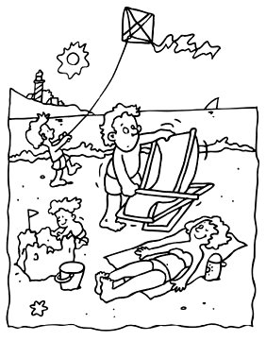

The kite is blue and purple. | The sand castle and the beach sand are yellow. | Father’s hair is brown.
The beach towel is pink. | Mother’s bikini is black. | Mother’s hair is blonde.
The beach bucket is orange. | Father’s beach shorts are dark green. | The sea foam is white.
Boys’ beach shorts are blue. | The light house is red and white. | The trees are green.
Father’s beach chair is red and brown. | The sun is yellow. | The sea star is red.
The sail boat is green. | The sky is blue. | Mother’s sun block is orange and yellow.
The ocean is blue. | Children’s hair is blonde. | The sand castle’s flag is grey.

